Landforms Study Guide

- The Earth's surface can be affected by two processes: Fast Processes and Slow Processes.
Label each of the processes as FAST or SLOW:

_________ deposition
_________ landslides
_________ volcanic eruptions
_________ floods
_________ weathering
_________ erosion
_________ earthquakes

- Earthquakes
- Fast Process that changes the surface of the Earth.
- Earthquakes are vibrations on Earth's surface caused by sudden movement in Earth, often along a fault, a break in Earth's surface.
- Large earthquakes can cause landslides.
- Earthquakes under the ocean can cause huge waves, called tsunamis that destroy land and cause great damage if they come ashore.

- Volcanic Eruptions
- Fast Process that changes the surface of the Earth.
- Volcanoes are mountains with openings in Earth's crust through which magma, gases, and ash reach Earth's surface.
- When lava cools it forms new land on the Earth’s surface.

- Landslides
- Fast Process that changes the surface of the Earth.
- Can be caused by an earthquake or a combination of lots of rain, erosion and gravity
- Landslides are mass movements of land due to gravity.
- Landslides can cause buildings to fall, or power or gas lines to break.

- Floods
- Floods occur when a large amount of water covers land that is usually dry.
- When the flood occurs, rapid erosion can take place and move soil and sediments away.
- When the flood is over, new sediment is left behind and can build up rich soil deposits.

- Weathering
- Weathering can be either physical or chemical
- Weathering is the process in which rocks are broken down
- These processes can cause the surface of the earth to dissolve, decompose, and break into smaller pieces.
- Water is an important cause of weathering.
- Plants cause weathering when roots break apart rock.
- Changes in temperature can break rock.
- Ice forming inside cracks in a rock can cause it to break even more.
- Anything that causes rocks to wear down or break apart is a cause of weathering.

- Erosion
- Erosion is the movement of sediments by wind, water, ice, and gravity.

- Deposition
- Deposition is the dropping, or depositing, of sediments by water, wind, or ice.
- Deposition builds up new land on Earth's surface, like a delta at the end of a river or the pile up of a sand dune in the desert.
- Shells on the beach are deposition by ocean waves.

Weathering vs. Erosion

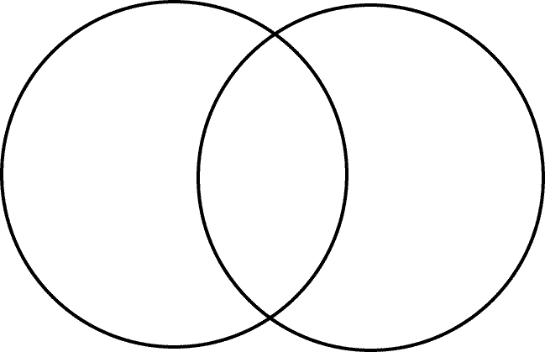
Caused by wind, water and ice
Creates new landforms
Shapes and carves the land
Moves rocks and particles
Helps weathering to continue
Caused by gravity, wind, water and glaciers (ice)

Softens rocks
Break down rocks
Creates soil, clay and sand
Caused by freezing and thawing
Wind
Water
Ice

Erosion
Weathering

Chemical Weathering

Physical Weathering

Erosion

Fossils
- The only direct way we have of learning about dinosaurs is by studying fossils. Fossils are the remains of ancient animals and plants, the traces or impressions of living things from past geologic ages, or the traces of their activities. Fossils have been found on every continent on Earth.
- Over long periods of time, these small pieces of debris are compressed (squeezed) and are buried under more and more layers of sediment that piles up on top of it. Eventually, they are compressed into sedimentary rock.
- Some animals were quickly buried after their death (by sinking in mud, being buried in a sandstorm, etc). Over time more and more sediment covered the remains. The parts of the animals that didn't rot (usually the harder parts like bones and teeth) were encased in the newly formed sediment. In the right circumstances (when there is no scavengers, quick burial, not much weathering) parts of the animal turned into fossils over time.
- After a long time the chemicals in the buried animals bodies underwent a series of changes. As the bone slowly decayed, water infused with minerals seeped into the bone and replaced the chemicals in the bone with rock-like minerals.
- In the end we get a heavy, rock-like copy of the original object - a fossil. The fossil has the same shape as the original object, but is chemically more like a rock!

